**Artificial Intelligence Lab**

Code: PMDS601P

**Digital Assignment 3**

**Name: Soumyadeep Ganguly**

**Reg. No.: 24MDT0082**

**Course: M.Sc in Data Science**

1. **Write a Prolog program defining a binary arithmetic predicate blahblah/2, which takes as its first argument a number X, and returns in its second argument the number XX + 2.**

**Code:**

blahblah(X, Y):-

XX is X**X,

Y is XX + 2.

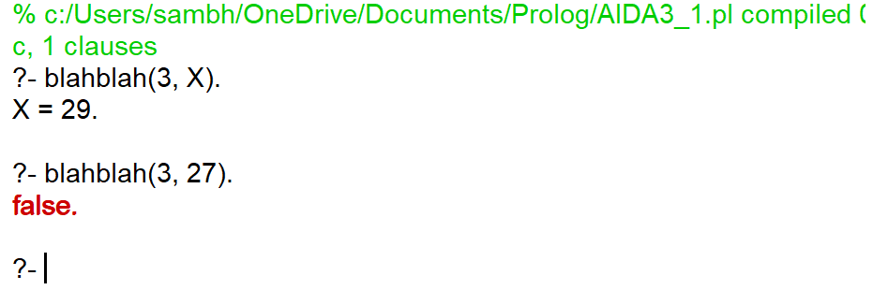**Output:**

**Convert blahblah/2 into a binary operator in the same file. For instance:**

**Code:**

:- op(500, xfx, blahblah).

blahblah(X, Y):-

XX is X**X,

Y is XX + 2.

**Output:**

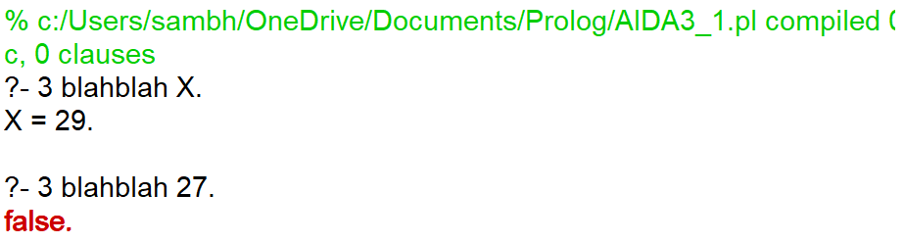

1. **Convert your previously defined predicates of set union and set intersection to appropriately defined operators.**

**Code:**

:- op(500, xfy, union).

:- op(500, xfy, intersection).

Set1 union Set2 :-

union(Set1, Set2, Result),

write('Union: '), write(Result).

Set1 intersection Set2 :-

intersection(Set1, Set2, Result),

write('Intersection: '), write(Result).

union([], B, B).

union([H|T], B, [H|U]) :-

\+ member(H, B),

union(T, B, U).

union([H|T], B, U) :-

member(H, B),

union(T, B, U).

intersection([], _, []).

intersection([H|T], B, [H|I]) :-

member(H, B),

intersection(T, B, I).

intersection([H|T], B, I) :-

\+ member(H, B),

intersection(T, B, I).

**Output:**

